**SARDAR VALLABHBHAI NATIONAL INSTITUTE OF TECHNOLOGY, SURAT**

**DEPARTMENT OF CIVIL ENGINEERING**

**ENVIRONMENTAL ENGINEERING SECTION**

Environmental Engineering section was established in the year 1961 during the inception of the Department of Civil Engineering, wing A. The laboratory facilities are mainly utilized by undergraduate and postgraduate students for their UG and PG curriculum laboratory work. Students pursuing research under Ph. D. program also utilize it for conducting various treatability studies under their study. The laboratory set up is also used to carry out various testing of water, wastewater air pollution, solid and hazardous waste management, and noise pollution parameters. The laboratory facility has good potential to carry out consultancy work generating revenue using the expertise of learned faculty members in the area of wastewater treatment, air pollution, solid and hazardous waste management, and noise pollution.

Environmental Engineering Section is running three (3) laboratories

1. Environmental Engineering Basic Laboratory
2. Solid Waste Management Laboratory
3. Environmental Audit Laboratory

Solid Waste Management Laboratory was established as per Gujarat State Urban Solid Waste Management and Sanitation Policy-2018 (Government of Gujarat Urban Development & Urban Housing Department G.R.No. SBM/132018/2844/Th-1 Sachivalaya, Gandhinagar Date: 31/7/2018) one of the major objective ( section 1.3) it was mentioned that 100% decentralized processing of biodegradable waste at neighborhood/ ward/zone level. Further section 8.3 Goal 3 it was mentioned that Separate collection & management of Waste from bulk generators: All resident welfare and market associations, gated colonies and institutions with an area of more than 5000 sq. m and all hotels and restaurants should ensure segregation of waste at source; facilitate collection of segregated waste and handover the recyclable material to either the authorized waste pickers/waste collectors or authorized recyclers. The bio-degradable waste from all bulk waste generators including vegetable, fruit, flower, meat poultry and fish market should be collected on day to day basis, processed, treated and disposed-off through composting or bio-methnation within the premises as far as possible.

Solid waste management laboratory is capable to carry out the analysis of

* Organic waste samples
* Soil samples
* Municipal solid waste samples
* Hazardous waste samples
* Sludge samples
* Fly ash samples

Solid waste management laboratories having a facility to work 24x7 with all basic facilities like personal computer, printer, scanner, drinking water facility, tea facility, etc. Laboratory is also generating the revenue by analyzing the samples and demonstrated to various stake holders.

Laboratory have followings equipment’s

|  |  |
| --- | --- |
| **Sr. No.** | **Equipment Name** |
| 1. | TKN Analyzer |
| 2. | Flame photometer |
| 3. | Muffle furnace |
| 4. | Deep freezer |
| 5. | Hot air oven |
| 6. | RDF shredder |
| 7. | Flower waste shredder |
| 8. | Leafy waste shredder |
| 9. | Flower waste composter |
| 10. | Garden waste composter |
| 11. | Rotary drum composter |
| 12. | Material blender |
| 13. | Weighing balance-100kg, 10, kg and 2 kg |
| 14. | pH Meter |
| 15. | Digestion plate |
| 16. | Electrical Conductivity Meter |
| 17. | Compressor |
| 18. | Tool kit |
| 19. | Vacuum Pump |
| 20. | Refrigerator |
| 21. | BOD Incubator |

Granted Patent for developed design and process :

1. Composter (Design No: 300440 Date of Issue: 01-02-2019)
2. Dry Leaves Cutting Machine (Design No: 320230-001 Date of Issue: 16-11-2020)
3. Flower Waste Pulveriser (Design No:334122-001 Date of Issue: 27-11-2020)
4. Rotatory Composter for Organic waste (Design No:336824-001 Date of Issue: 02-02-2021)
5. Flower waste composter (Design No:331236-001 Date of Issue: 09-06-2021)
6. Garden Waste Shredder (Design No: 348117-001 Date of Issue: 06-10-2021)
7. A System for Composting of Flower Waste and A Method Thereof (Process Patent No. 381773 Date of Issue: 12-11-2021)

**Flower Waste composter**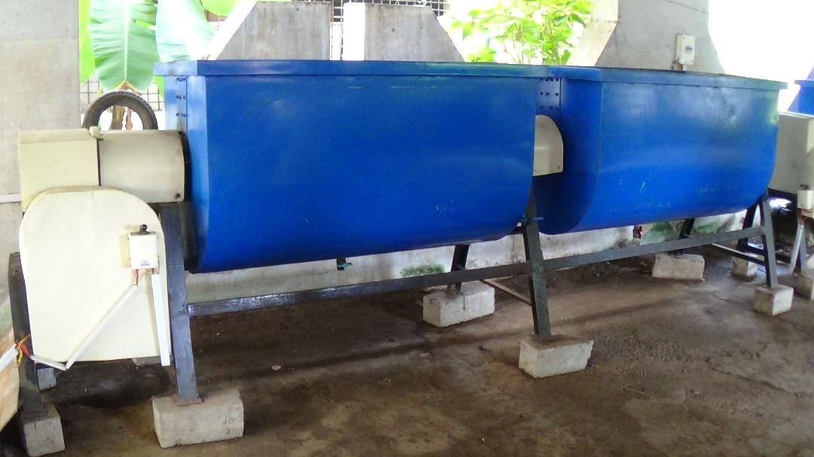

**Garden Waste composter**

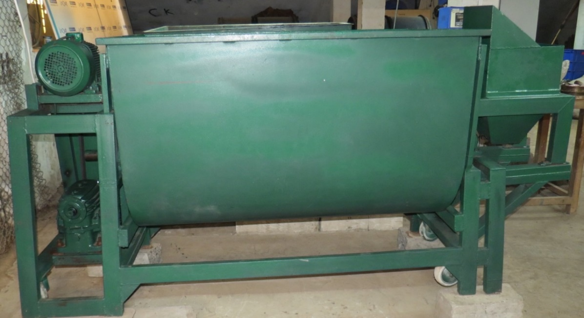

|  |  |
| --- | --- |
|  | C:\Users\Admin\Desktop\215752be-f9b8-473a-937b-c7271614ba9b.jpg |
| **Flower waste shredder** | **RDF shredder** |
|  |  |
|  |  |